**Open the ticket and go to view log and copy the USO sales order in the view log.**

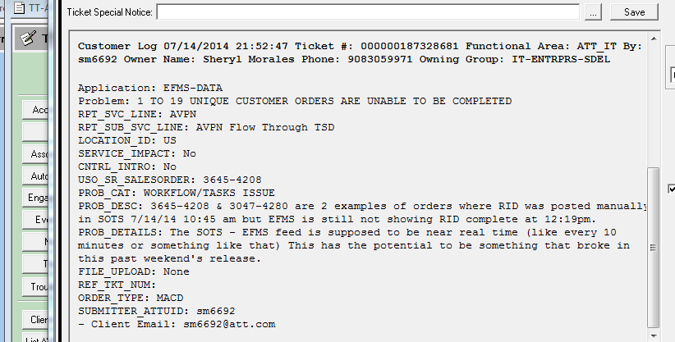

**Copy the SALESORDER**

**Then run the SQL statement in SQL DEVELOPER.**

**Select ORDER_NUMBER,SVC_ORDER_ID,CLCI,STATUS from svc_order where order_number = ‘put the uso salesorder here’ ;**

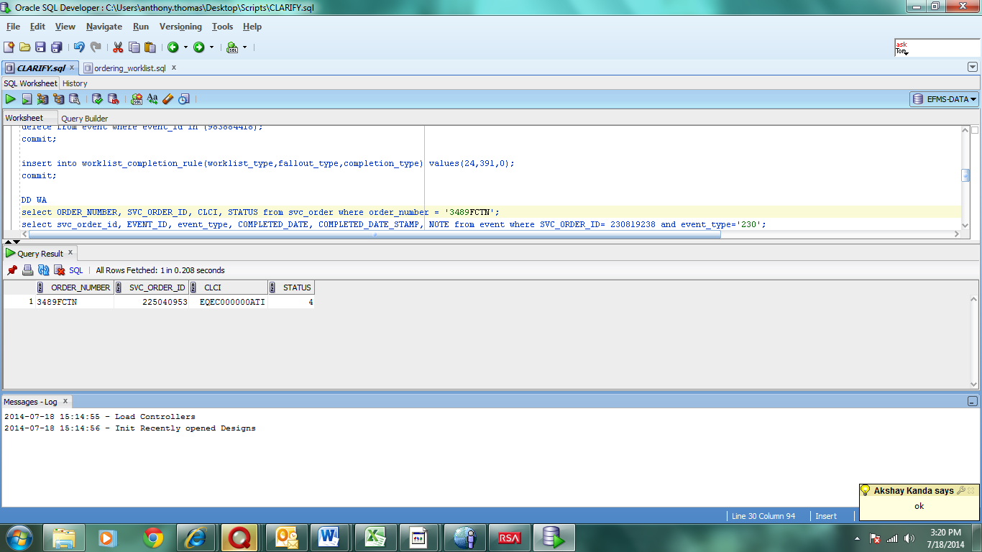

**SVC_ORDER_ID**

**USO SALESORDER**

**After running the first SQL statement, we get the svc-ord-id and populate the second statement...**

**COPY THE SVC_ORDER_ID. RUN THE SECOND SQL STATEMENT BY USING THE SVC_ORDER_ID.**

**Select SVC_ORDER_ID,EVENT ID,event_type, completed_date,COMPLETED_DATE_STAMP, NOTE from event where SVC_ORDER_ID=(PUT THE SVC_ORDER_ID) AND event_type=’230’;**

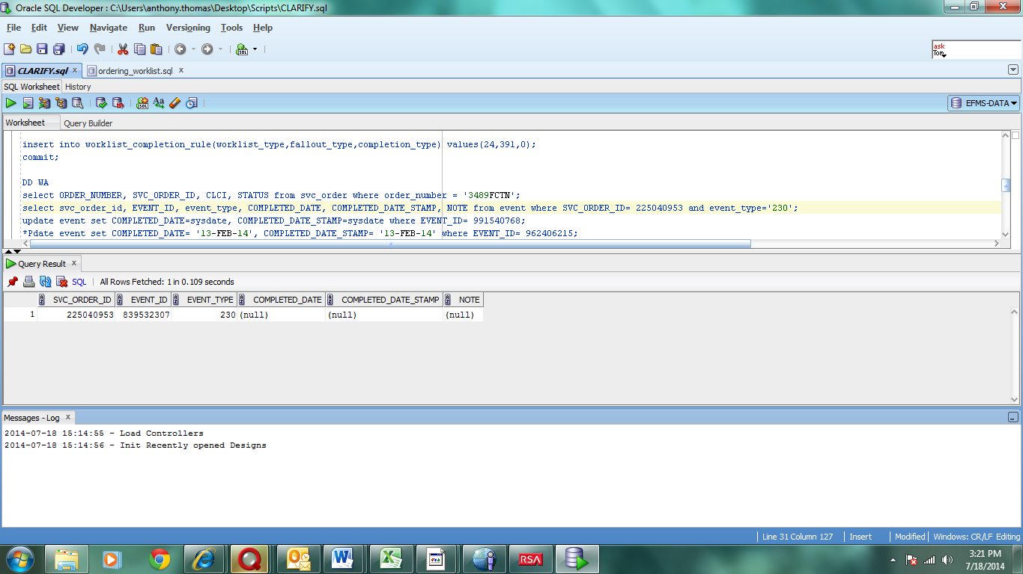

**EVENT_ID**

**SVC_ORDER_ID**

**Then we take the Event Id and populate the 3rd SQL statement**

**UPDATE event set,completed_date=sysdate,COMPLETE_DATE_STAMP=sysdate where event_id=(put the event_id here);**

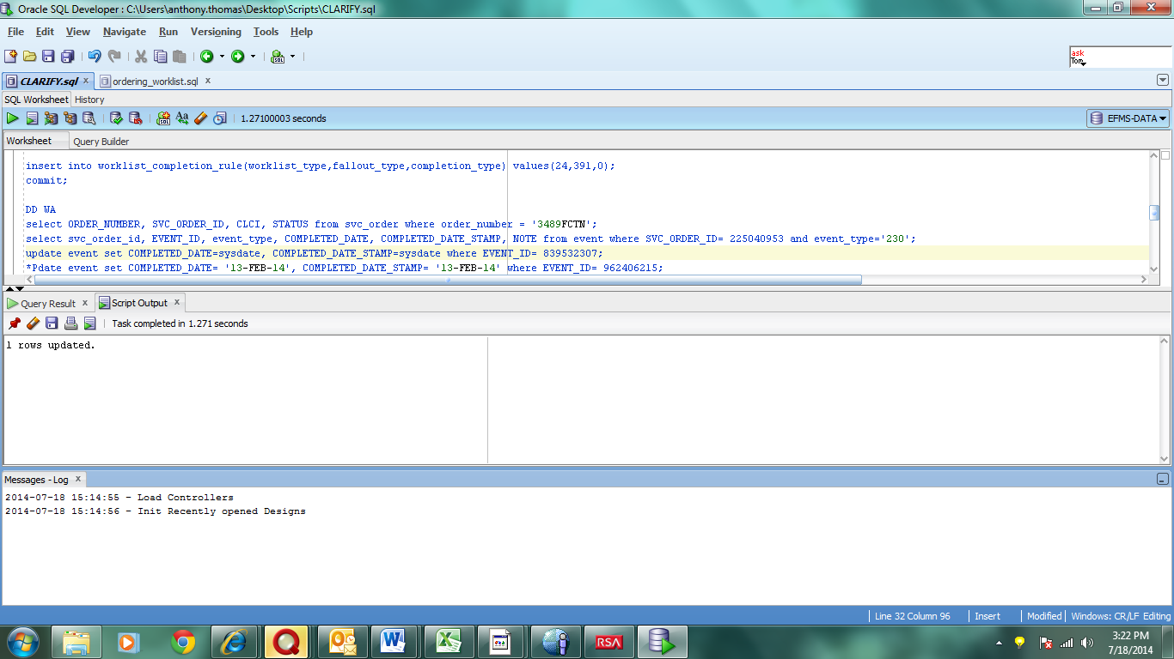

**EVENT_ID**

**Then we run the 4th statement, an Update with the same USO value as the First SQL statement....**

**Update svc_order set STATUS=1 where order_number = ‘PUT USO_SALES_ORDER’**

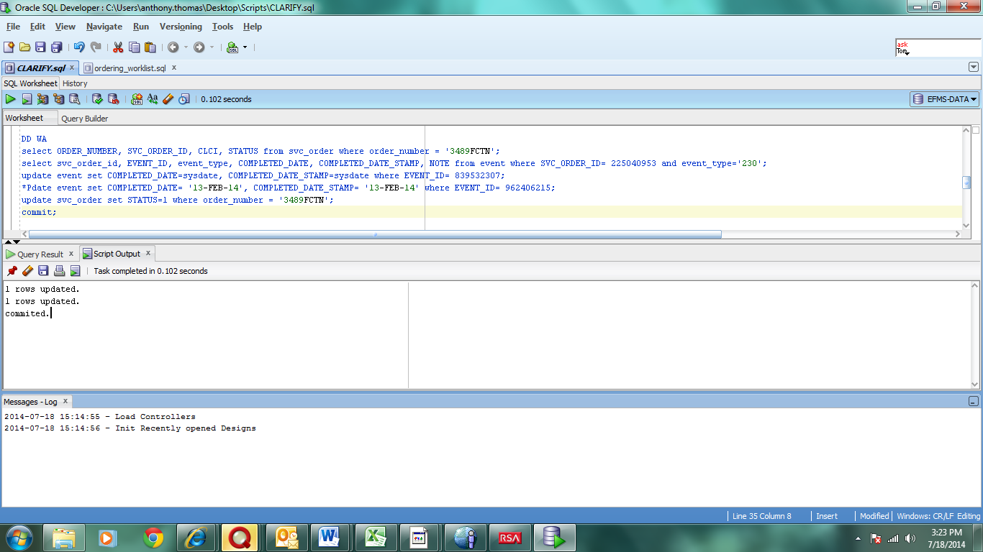

**USO_SALES_ORDER**

**After the running SQL statements, we close the ticket by Qing the user, pasting the Q in the ticket, populating the Time and Resolution Tab and setting the ticket to RTC (ready to close).**